CodeHelp

### LEC-1: Introduction to DBMS

##### What is Data?

* 1. Data is a collection of raw, unorganized facts and details like text, observations, figures, symbols, and descriptions of things etc.

In other words, **data does not carry any specific purpose and has no significance by itself.** Moreover, data is measured in terms of bits and bytes – which are basic units of information in the context of computer storage and processing.

* 1. Data can be recorded and doesn’t have any meaning unless processed.

##### Types of Data

* 1. **Quantitative**
     1. Numerical form
     2. Weight, volume, cost of an item.

##### Qualitative

* + 1. Descriptive, but not numerical.
    2. Name, gender, hair color of a person.

1. What is **Information**?

##### Info. Is processed, organized, and structured data.

* 1. It provides **context of the data and enables decision making.**
  2. Processed data that make **sense** to us.
  3. Information is extracted from the data, by **analyzing and interpreting** pieces of data.
  4. E.g., you have data of all the people living in your locality, its Data, when you analyze and interpret the data and come to some conclusion that:
     1. There are 100 senior citizens.
     2. The sex ratio is 1.1.
     3. Newborn babies are 100. These are information.

##### Data vs Information

* 1. Data is a collection of facts, while information puts those facts into context.
  2. While data is raw and unorganized, information is organized.
  3. Data points are individual and sometimes unrelated. Information maps out that data to provide a big-picture view of how it all fits together.
  4. Data, on its own, is meaningless. When it’s analyzed and interpreted, it becomes meaningful information.
  5. Data does not depend on information; however, information depends on data.
  6. Data typically comes in the form of graphs, numbers, figures, or statistics. Information is typically presented through words, language, thoughts, and ideas.
  7. Data isn’t sufficient for **decision-making**, but you can make decisions based on information.

1. What is **Database**?
   1. Database is an electronic place/system where data is stored in a way that it can be **easily accessed, managed, and updated.**
   2. To make real use Data, we need **Database management systems. (DBMS)**
2. What is **DBMS**?
   1. A database-management system (DBMS) is a collection of **interrelated data** and **a set of programs to access those data**. The collection of data, usually referred to as the **database**, contains information relevant to an enterprise. The primary goal of a DBMS is to provide a way to **store and retrieve database information** that is both convenient and efficient.
   2. A DBMS is the database itself, along with all the software and functionality. It is used to perform different operations, like **addition**, **access**, **updating**, and **deletion** of the data.

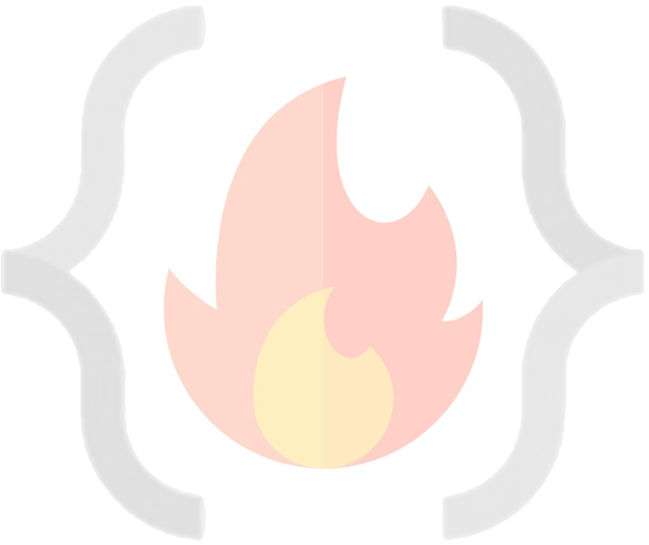

CodeHelp

1. 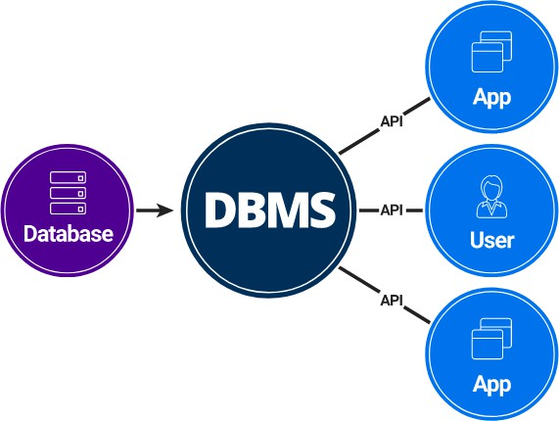​

##### DBMS vs File Systems

* 1. **File-processing systems** has major **disadvantages**.
     1. Data Redundancy and inconsistency
     2. Difficulty in accessing data
     3. Data isolation
     4. Integrity problems
     5. Atomicity problems
     6. Concurrent-access anomalies
     7. Security problems
  2. Above 7 are also the **Advantages of DBMS** (answer to “**Why to use DBMS?**”)

CodeHelp

### LEC-2: DBMS Architecture

##### View of Data (Three Schema Architecture)

* 1. The major purpose of DBMS is to provide users with an **abstract view** of the data. That is, the system hides certain details of how the data is stored and maintained.
  2. To simplify user interaction with the system, abstraction is applied through several levels of abstraction.
  3. The **main objective** of three level architecture is to enable multiple users to access the same data with a personalized view while storing the underlying data only once

##### Physical level / Internal level

* + 1. The lowest level of abstraction describes how the data are stored.
    2. Low-level data structures used.
    3. It has **Physical schema** which describes physical storage structure of DB.
    4. Talks about: Storage allocation (N-ary tree etc), Data compression G encryption etc.
    5. **Goal**: We must define algorithms that allow efficient access to data.

##### Logical level / Conceptual level:

* + 1. The **conceptual schema** describes the design of a database at the conceptual level, describes ***what*** data are stored in DB, and what ***relationships*** exist among those data.
    2. User at logical level does not need to be aware about physical-level structures.
    3. **DBA**, who must decide what information to keep in the DB use the logical level of abstraction.
    4. **Goal**: ease to use.

##### View level / External level:

* + 1. Highest level of abstraction aims to simplify users’ interaction with the system by providing different view to different **end**-user.
    2. Each **view schema** describes the database part that a particular user group is interested and hides the remaining database from that user group.
    3. At the external level, a database contains several schemas that sometimes called as

**subschema**. The subschema is used to describe the different view of the database.

* + 1. At views also provide a **security** mechanism to prevent users from accessing certain parts of DB.
  1. 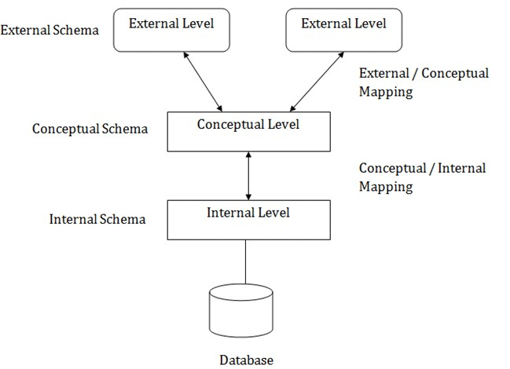

##### Instances and Schemas

* 1. The collection of information stored in the DB at a particular moment is called an **instance** of DB.
  2. The overall design of the DB is called the DB **schema**.
  3. Schema is **structural** description of data. Schema **doesn’t change frequently**. Data may change frequently.
  4. **DB schema** corresponds to the variable declarations (along with type) in a program.
  5. We have 3 types of **Schemas**: **Physical, Logical**, several **view schemas** called subschemas.
  6. Logical schema is most **important** in terms of its effect on application programs, as programmers construct apps by using logical schema.
  7. **Physical data independence**, physical schema change should not affect logical schema/application programs.

##### Data Models:

* 1. Provides a way to describe the **design** of a DB at **logical level.**
  2. Underlying the structure of the DB is the Data Model; a collection of conceptual tools for describing

##### data, data relationships, data semantics G consistency constraints.

* 1. E.g., **ER** model, **Relational** Model, **object-oriented** model, **object-relational** data model etc.

##### Database Languages:

* 1. **Data definition language (DDL)** to specify the database schema.
  2. **Data manipulation language (DML)** to express database queries and updates.
  3. **Practically**, both language features are present in a single DB language, e.g., SQL language.
  4. DDL
  5. DML

1. We specify consistency constraints, which must be checked, every time DB is updated.
2. Data manipulation involves
   1. **Retrieval** of information stored in DB.
   2. **Insertion** of new information into DB.
   3. **Deletion** of information from the DB.
   4. **Updating** existing information stored in DB.
3. **Query language**, a part of DML to specify statement requesting the retrieval of information.

##### How is Database accessed from Application programs?

CodeHelp

* 1. Apps (written in host languages, C/C++, Java) interacts with DB.
  2. E.g., Banking system’s module generating payrolls access DB by executing DML statements from the host language.
  3. API is provided to send DML/DDL statements to DB and retrieve the results.
     1. Open Database Connectivity (**ODBC**), Microsoft “C”.
     2. Java Database Connectivity (**JDBC**), Java.

##### Database Administrator (DBA)

* 1. A person who has **central control** of both the data and the programs that access those data.
  2. **Functions** of DBA
     1. Schema Definition
     2. Storage structure and access methods.
     3. Schema and physical organization modifications.
     4. Authorization control.
     5. Routine maintenance
        1. Periodic backups.
        2. Security patches.
        3. Any upgrades.

1. **DBMS Application Architectures**: Client machines, on which remote DB users work, and server machines on which DB system runs.
   1. **T1** Architecture
      1. The client, server G DB all present on the same machine.

CodeHelp

* 1. **T2** Architecture
     1. App is partitioned into 2-components.
     2. Client machine, which invokes DB system functionality at server end through query language statements.
     3. API standards like **ODBC** G **JDBC** are used to interact between client and server.
  2. **T3** Architecture
     1. App is partitioned into 3 logical components.
     2. Client machine is just a frontend and doesn’t contain any direct DB calls.
     3. Client machine communicates with App server, and App server communicated with DB system to access data.
     4. **Business** logic, what action to take at that condition is in App server itself.
     5. T3 architecture are best for **WWW** Applications.

##### Advantages:

* + - 1. **Scalability** due to distributed application servers.
      2. **Data integrity**, App server acts as a middle layer between client and DB, which minimize the chances of data corruption.
      3. **Security**, client can’t directly access DB, hence it is more secure.

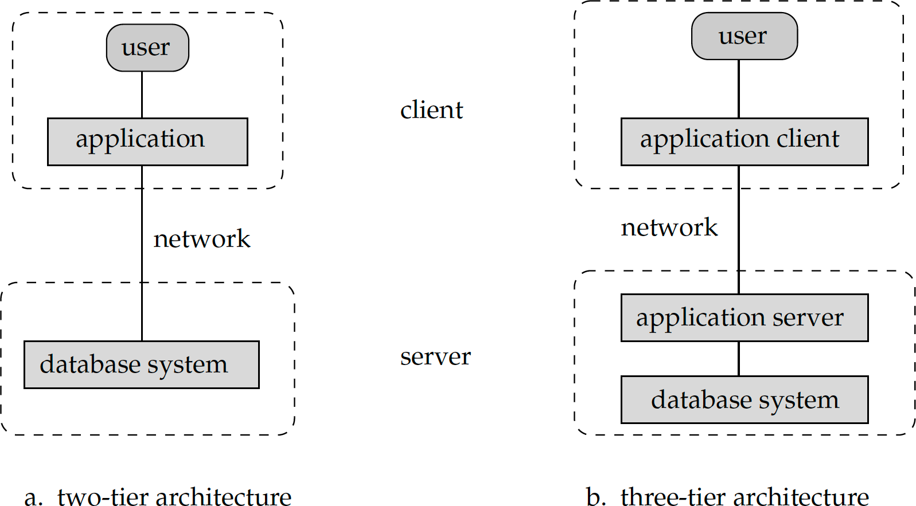

### LEC-3: Entity-Relationship Model

1. **Data Model**: Collection of conceptual tools for **describing data, data relationships, data semantics, and consistency constraints.**

##### ER Model

* 1. It is a high level data model based on a perception of a **real** world that consists of a collection of basic objects, called

**entities** and of **relationships** among these objects.

* 1. Graphical representation of ER Model is **ER diagram,** which acts as a **blueprint** of DB.
  2. **Entity**: An Entity is a “**thing**” or “**object**” in the real world that is **distinguishable** from all other objects.
     1. It has **physical existence**.
     2. Each student in a college is an entity.
     3. Entity can be **uniquely** identified. (By a primary aUribute, aka Primary Key)
     4. **Strong Entity**: Can be uniquely identified.
     5. **Weak Entity**: Can’t be uniquely identified., depends on some other strong entity.
        1. It doesn’t have suﬃcient aUributes, to select a uniquely identifiable aUribute.
        2. Loan -> Strong Entity, Payment -> Weak, as instalments are sequential number counter can be generated separate for each loan.

##### Weak entity depends on strong entity for existence.

* + - 1. **Entity set**
         1. It is a set of entities of the **same** type that share the **same** properties, or aUributes.
         2. E.g., Student is an entity set.
         3. E.g., Customer of a bank

##### AUributes

CodeHelp

* + - * 1. An entity is represented by a set of aUributes.
        2. Each entity has a value for each of its aUributes.
        3. For each aUribute, there is a set of **permiUed values**, called the **domain**, or **value** set, of that aUribute.
        4. E.g., Student Entity has following aUributes

Student_ID

Name

Standard

Course

Batch

Contact number

Address

##### Types of AUributes

1. **Simple**
   1. AUributes which can’t be divided further.
   2. E.g., Customer’s account number in a bank, Student’s Roll number etc.

##### Composite

* 1. Can be divided into subparts (that is, other aUributes).
  2. E.g., Name of a person, can be divided into first-name, middle-name, last-name.
  3. If user wants to refer to an entire aUribute or to only a component of the aUribute.
  4. Address can also be divided, street, city, state, PIN code.

##### Single-valued

* 1. Only one value aUribute.
  2. e.g., Student ID, loan-number for a loan.

##### Multi-valued

* 1. AUribute having more than one value.
  2. e.g., phone-number, nominee-name on some insurance, dependent-name etc.
  3. Limit constraint may be applied, upper or lower limits.

##### Derived

* 1. Value of this type of aUribute can be derived from the value of other related aUributes.
  2. e.g., Age, loan-age, membership-period etc.

##### NULL Value

1. An aUribute takes a null value when an entity does not have a value for it.
2. It may indicate “not applicable”, value doesn’t exist. e.g., person having no middle-name
3. It may indicate “unknown”.
   1. Unknown can indicate missing entry, e.g., name value of a customer is NULL, means it is missing as name must have some value.
   2. Not known, salary aUribute value of an employee is null, means it is not known yet.

##### Relationships

* + - * 1. **Association** among two or more entities.
        2. e.g., Person has vehicle, Parent has Child, Customer borrow loan etc.
        3. **Strong Relationship**, between two independent entities.
        4. **Weak Relationship**, between weak entity and its owner/strong entity.

1. e.g., Loan <instalment-payments> Payment.

##### Degree of Relationship

1. Number of entities participating in a relationship.
2. **Unary**, Only one entity participates. e.g., Employee manages employee.
3. **Binary**, two entities participates. e.g., Student takes Course.
4. **Ternary** relationship, three entities participates. E.g, Employee works-on branch, employee works-on job.
5. Binary are **common**.

##### Relationships Constraints

* + - * 1. **Mapping Cardinality / Cardinality Ratio**

1. Number of entities to which another entity can be associated via a relationship.

CodeHelp

1. **One to one,** Entity in A associates with at most one entity in B, where A G B are entity sets. And an entity of B is associated with at most one entity of A.
   1. E.g., Citizen has Aadhar Card.
2. **One to many,** Entity in A associated with N entity in B. While entity in B is associated with at most one entity in A.
   1. e.g., Citizen has Vehicle.
3. **Many to one,** Entity in A associated with at most one entity in B. While entity in B can be associated with N entity in A.
   1. e.g., Course taken by Professor.
4. **Many to many,** Entity in A associated with N entity in B. While entity in B also associated with N entity in A.
   1. Customer buys product.
   2. Student aUend course.

##### Participation Constraints

1. Aka, **Minimum cardinality constraint.**
2. **Types**, Partial G Total Participation.
3. **Partial Participation,** not all entities are involved in the relationship instance.
4. **Total Participation**, each entity must be involved in at least one relationship instance.
5. e.g., Customer borrow loan, loan has total participation as it can’t exist without customer entity. And customer has partial participation.
6. **Weak entity has total participation constraint, but strong may not have total.**
   * + 1. **ER Notations**

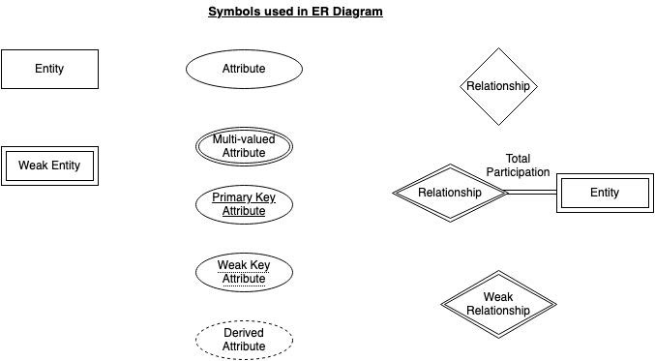

CodeHelp

### LEC-4: Extended ER Features

1. **Basic ER Features** studied in the **LEC-3,** can be used to model most DB features but when complexity increases, it is beUer to use some Extended ER features to model the DB Schema.

##### Specialisation

* 1. In ER model, we may require to subgroup an entity set into other entity sets that are distinct in some way with other entity sets.
  2. **Specialisation** is **spliUing** up the entity set into further **sub entity sets** on the basis of their **functionalities**, **specialities** and **features**.
  3. It is a **Top-Down** approach.
  4. e.g., **Person** entity set can be divided into **customer**, **student**, **employee**. Person is **superclass** and other specialised entity sets are **subclasses**.
     1. We have **“is-a”** relationship between superclass and subclass.
     2. Depicted by **triangle** component.
  5. **Why** Specialisation?
     1. Certain aUributes may only be applicable to a few entities of the parent entity set.
     2. DB designer can show the distinctive features of the sub entities.
     3. To group such entities we apply Specialisation, to overall **refine** the DB blueprint.

##### Generalisation

* 1. It is just a **reverse** of Specialisation.
  2. DB Designer, may encounter certain properties of two entities are overlapping. Designer may consider to make a new generalised entity set. That generalised entity set will be a super class.

CodeHelp

* 1. **“is-a”** relationship is present between subclass and super class.
  2. e.g., **Car**, **Jeep** and **Bus** all have some common aUributes, to avoid data repetition for the common aUributes. DB designer may consider to Generalise to a new entity set “**Vehicle**”.
  3. It is a **BoUom-up** approach.
  4. **Why** Generalisation?
     1. Makes DB more **refined** and **simpler**.
     2. Common aUributes are not **repeated**.

##### AUribute Inheritance

* 1. **Both** Specialisation and Generalisation, has aUribute inheritance.
  2. The aUributes of higher level entity sets are inherited by lower level entity sets.
  3. E.g., **Customer G Employee** inherit the aUributes of **Person**.

##### Participation Inheritance

* 1. If a parent entity set participates in a relationship then its child entity sets will also participate in that relationship.

##### Aggregation

* 1. **How to show relationships among relationships?** - Aggregation is the technique.
  2. **Abstraction** is applied to treat relationships as higher-level entities. We can call it Abstract entity.
  3. **Avoid redundancy** by aggregating relationship as an entity set itself.

### LEC-7: Relational Model

1. Relational Model (RM) organises the data in the form of **relations** (**tables**).
2. A relational DB consists of **collection of tables**, each of which is assigned a **unique name.**
3. A **row** in a table represents a relationship among a set of values, and table is collection of such relationships.
4. **Tuple**: A single row of the table representing a single data point / a unique record.
5. **Columns**: represents the aUributes of the relation. Each aUribute, there is a permiUed value, called **domain of the aUribute.**
6. **Relation Schema**: defines the design and structure of the relation, contains the name of the relation and all the columns/aUributes.
7. Common RM based DBMS systems, aka RDBMS: Oracle, IBM, **MySQL**, MS Access.
8. **Degree of table:** number of aUributes/columns in a given table/relation.
9. **Cardinality**: Total no. of tuples in a given relation.
10. **Relational Key**: Set of aUributes which can uniquely identify an each tuple.
11. Important **properties** of a **Table** in Relational Model
    1. The name of relation is distinct among all other relation.
    2. The values have to be atomic. Can’t be broken down further.
    3. The name of each aUribute/column must be unique.
    4. Each tuple must be unique in a table.
    5. The sequence of row and column has no significance.
    6. Tables must follow integrity constraints - it helps to maintain data consistency across the tables.

##### Relational Model Keys

* 1. Super Key (**SK**): Any PGC of aUributes present in a table which can uniquely identify each tuple.

CodeHelp

* 1. Candidate Key (**CK**): minimum subset of super keys, which can uniquely identify each tuple. It contains no redundant aUribute.

##### CK value shouldn’t be NULL.

* 1. Primary Key (**PK**):
     1. Selected out of CK set, has the least no. of aUributes.
  2. Alternate Key (**AK**)
     1. All CK except PK.
  3. Foreign Key (**FK**)
     1. It creates relation between two tables.
     2. A relation, say r1, may include among its aUributes the PK of an other relation, say r2. This aUribute is called FK from r1 referencing r2.
     3. The relation r1 is aka **Referencing (Child) relation** of the FK dependency, and r2 is called **Referenced (Parent) relation** of the FK.
     4. FK helps to cross reference between two different relations.
  4. **Composite** Key: PK formed using at least 2 aUributes.
  5. **Compound** Key: PK which is formed using 2 FK.
  6. **Surrogate** Key:
     1. Synthetic PK.
     2. Generated automatically by DB, usually an integer value.
     3. May be used as PK.

##### Integrity Constraints

* 1. CRUD Operations must be done with some integrity policy so that DB is always consistent.
  2. Introduced so that we do not accidentally corrupt the DB.

##### Domain Constraints

* + 1. Restricts the value in the aUribute of relation, specifies the Domain.
    2. Restrict the Data types of every aUribute.
    3. E.g., We want to specify that the enrolment should happen for candidate birth year < 2002.

##### Entity Constraints

* + 1. Every relation should have PK. PK != NULL.

##### Referential Constraints

* + 1. Specified between two relations G helps maintain consistency among tuples of two relations.
    2. It requires that the value appearing in specified aUributes of any tuple in referencing relation also appear in the specified aUributes of at least one tuple in the referenced relation.
    3. If FK in referencing table refers to PK of referenced table then every value of the FK in referencing table must be NULL or available in referenced table.
    4. FK must have the matching PK for its each value in the parent table or it must be NULL.
  1. **Key Constraints:** The six types of key constraints present in the Database management system are:-
     1. NOT NULL: This constraint will restrict the user from not having a NULL value. It ensures that every element in the database has a value.
     2. UNIQUE: It helps us to ensure that all the values consisting in a column are different from each other.
     3. DEFAULT: it is used to set the default value to the column. The default value is added to the columns if no value is specified for them.
     4. CHECK: It is one of the integrity constraints in DBMS. It keeps the check that integrity of data is maintained before and aier the completion of the CRUD.
     5. PRIMARY KEY: This is an aUribute or set of aUributes that can uniquely identify each entity in the entity set. The primary key must contain unique as well as not null values.
     6. FOREIGN KEY: Whenever there is some relationship between two entities, there must be some common aUribute between them. This common aUribute must be the primary key of an entity set and will become the foreign key of another entity set. This key will prevent every action which can result in loss of connection between tables.

CodeHelp

### LEC-8: Transform - ER Model to Relational Model

1. Both **ER**-Model and **Relational** Model are abstract logical representation of real world enterprises. Because the two models implies the similar design principles, **we can convert ER design into Relational design**.
2. Converting a DB representation from an ER diagram to a table format is the way we arrive at Relational DB-design from an ER diagram.
3. ER diagram **notations to relations**:

##### Strong Entity

* + 1. Becomes an **individual table** with entity name, aUributes becomes columns of the relation.
    2. Entity’s Primary Key (PK) is used as Relation’s PK.
    3. **FK** are added to establish relationships with other relations.

##### Weak Entity

* + 1. A table is formed with all the aUributes of the entity.
    2. PK of its corresponding Strong Entity will be added as **FK**.
    3. **PK** of the relation will be a composite PK, {FK + Partial discriminator Key}.

##### Single Values AUributes

* + 1. Represented as **columns** directly in the tables/relations.

##### Composite AUributes

* + 1. Handled by **creating a separate aUribute** itself in the original relation for each composite aUribute.
    2. e.g., **Address**: {street-name, house-no}, is a composite aUribute in customer relation, we add address-street- name G address-house-name as new columns in the aUribute and ignore “address” as an aUribute.

##### Multivalued AUributes

* + 1. **New tables** (named as original aUribute name) are created for each multivalued aUribute.

CodeHelp

* + 1. PK of the entity is used as column **FK** in the new table.
    2. Multivalued aUribute’s similar name is added as a column to define multiple values.
    3. **PK** of the new table would be {FK + multivalued name}.
    4. e.g., For Strong entity **Employee**, **dependent-name** is a multivalued aUribute.
       1. New table named dependent-name will be formed with columns emp-id, and dname.
       2. PK: {emp-id, name}
       3. FK: {emp-id}
  1. **Derived AUributes**: Not considered in the tables.

##### Generalisation

* + 1. **Method-1:** Create a table for the higher level entity set. For each lower-level entity set, create a table that includes a column for each of the aUributes of that entity set plus a column for each aUribute of the primary key of the higher-level entity set.

For e.g., Banking System generalisation of Account - saving G current.

* + - 1. Table 1: account (account-number, balance)
      2. Table 2: savings-account (account-number, interest-rate, daily-withdrawal-limit)
      3. Table 3: current-account (account-number, overdrai-amount, per-transaction-charges)
    1. **Method-2:** An alternative representation is possible, if the generalisation is disjoint and complete—that is, if no entity is a member of two lower-level entity sets directly below a higher-level entity set, and if every entity in the higher level entity set is also a member of one of the lower-level entity sets. Here, do not create a table for the higher-level entity set. Instead, for each lower-level entity set, create a table that includes a column for each of the aUributes of that entity set plus a column for each aUribute of the higher-level entity sets.

Tables would be:

* + - 1. Table 1: savings-account (account-number, balance, interest-rate, daily-withdrawal-limit)
      2. Table 2: current-account (account-number, balance, overdrai-amount, per-transaction-charges)
      3. **Drawbacks of Method-2:** If the second method were used for an overlapping generalisation, some values such as balance would be stored twice unnecessarily. Similarly, if the generalisation were not complete—that is, if some accounts were neither savings nor current accounts—then such accounts could not be represented with the second method.

##### Aggregation

CodeHelp

* + 1. Table of the relationship set is made.
    2. AUributes includes primary keys of entity set and aggregation set’s entities.
    3. Also, add descriptive aUribute if any on the relationship.

### LEC-9: SQL in 1-Video

1. **SQL**: Structured Query Language, used to access and manipulate data.
2. SQL used **CRUD** operations to communicate with DB.
   1. **CREATE** - execute INSERT statements to insert new tuple into the relation.
   2. **READ** - Read data already in the relations.
   3. **UPDATE** - Modify already inserted data in the relation.
   4. **DELETE** - Delete specific data point/tuple/row or multiple rows.

##### SQL is not DB, is a query language.

1. What is **RDBMS**? (Relational Database Management System)
   1. Soiware that enable us to implement designed relational model.
   2. e.g., MySQL, MS SQL, Oracle, IBM etc.
   3. Table/Relation is the simplest form of data storage object in R-DB.
   4. **MySQL** is open-source RDBMS, and it uses SQL for all CRUD operations
   5. **MySQL** used client-server model, where client is CLI or frontend that used services provided by MySQL server.

##### Difference between SQL and MySQL

* + 1. SQL is Structured Query language used to perform CRUD operations in R-DB, while MySQL is a RDBMS used to store, manage and administrate DB (provided by itself) using SQL.

**SQL DATA TYPES** (Ref: hUps[://www.w3schools.com/sql/sql_datatypes.asp)](http://www.w3schools.com/sql/sql_datatypes.asp))

1. In SQL DB, data is stored in the form of tables.
2. Data can be of different types, like INT, CHAR etc.

**DATATYPE**

CodeHelp

|  |  |
| --- | --- |
| **DATATYPE** | **Description** |
| CHAR | string(0-255), string with size = (0, 255], e.g., CHAR(251) |
| VARCHAR | string(0-255) |
| TINYTEXT | String(0-255) |
| TEXT | string(0-65535) |
| BLOB | string(0-65535) |
| MEDIUMTEXT | string(0-16777215) |
| MEDIUMBLOB | string(0-16777215) |
| LONGTEXT | string(0-4294967295) |
| LONGBLOB | string(0-4294967295) |
| TINYINT | integer(-128 to 127) |
| SMALLINT | integer(-32768 to 32767) |
| MEDIUMINT | integer(-8388608 to 8388607) |
| INT | integer(-2147483648 to 2147483647) |
| BIGINT | integer (-9223372036854775808 to  9223372036854775807) |
| FLOAT | Decimal with precision to 23 digits |
| DOUBLE | Decimal with 24 to 53 digits |



|  |  |
| --- | --- |
| **DATATYPE** | **Description** |
| DECIMAL | Double stored as string |
| DATE | YYYY-MM-DD |
| DATETIME | YYYY-MM-DD HH:MM:SS |
| TIMESTAMP | YYYYMMDDHHMMSS |
| TIME | HH:MM:SS |
| ENUM | One of the preset values |
| SET | One or many of the preset values |
| BOOLEAN | 0/1 |
| BIT | e.g., BIT(n), n upto 64, store values in bits. |

1. Size: TINY < SMALL < MEDIUM < INT < BIGINT.
2. **Variable length Data types** e.g., VARCHAR, are beUer to use as they occupy space equal to the actual data size.
3. Values can also be unsigned e.g., INT UNSIGNED.

##### Types of SQL commands:

* 1. **DDL** (data definition language): defining relation schema.
     1. **CREATE**: create table, DB, view.

CodeHelp

* + 1. **ALTER TABLE**: modification in table structure. e.g, change column datatype or add/remove columns.
    2. **DROP**: delete table, DB, view.
    3. **TRUNCATE**: remove all the tuples from the table.
    4. **RENAME**: rename DB name, table name, column name etc.
  1. **DRL/DQL** (data retrieval language / data query language): retrieve data from the tables.

#### SELECT

* 1. **DML** (data modification language): use to perform modifications in the DB
     1. **INSERT**: insert data into a relation
     2. **UPDATE**: update relation data.
     3. **DELETE**: delete row(s) from the relation.
     4. **DCL** (Data Control language): grant or revoke authorities from user.
        1. **GRANT**: access privileges to the DB
        2. **REVOKE**: revoke user access privileges.
     5. **TCL** (Transaction control language): to manage transactions done in the DB
        1. **START TRANSACTION**: begin a transaction
        2. **COMMIT**: apply all the changes and end transaction
        3. **ROLLBACK**: discard changes and end transaction
        4. **SAVEPOINT**: checkout within the group of transactions in which to rollback.

#### MANAGING DB (DDL)

##### Creation of DB

* 1. **CREATE DATABASE IF NOT EXISTS db-name;**
  2. **USE** db-name; //need to execute to choose on which DB CREATE TABLE etc commands will be executed.

//make switching between DBs possible.

* 1. **DROP** DATABASE IF EXISTS db-name; //dropping database.
  2. **SHOW** DATABASES; //list all the DBs in the server.
  3. **SHOW** TABLES; //list tables in the selected DB.

#### DATA RETRIEVAL LANGUAGE (DRL)

1. Syntax: SELECT <set of column names> FROM <table_name>;
2. Order of execution from RIGHT to LEFT.
3. Q. Can we use SELECT keyword without using FROM clause?
   1. Yes, using DUAL Tables.
   2. Dual tables are dummy tables created by MySQL, help users to do certain obvious actions without referring to user defined tables.
   3. e.g., SELECT 55 + 11; SELECT now();

SELECT ucase(); etc.

#### WHERE

* 1. Reduce rows based on given conditions.
  2. E.g., SELECT * FROM customer WHERE age > 18;

#### BETWEEN

* 1. SELECT * FROM customer WHERE age between 0 **AND** 100;
  2. In the above e.g., 0 and 100 are inclusive.

#### IN

* 1. Reduces **OR** conditions;
  2. e.g., SELECT * FROM oﬃcers WHERE oﬃcer_name IN ('Lakshay', ‘Maharana Pratap', ‘Deepika’);

#### AND/OR/NOT

* 1. AND: WHERE cond1 AND cond2
  2. OR: WHERE cond1 OR cond2
  3. NOT: WHERE col_name NOT IN (1,2,3,4);

CodeHelp

#### IS NULL

* 1. e.g., SELECT * FROM customer WHERE prime_status is NULL;

##### PaUern Searching / Wildcard (‘%’, ‘_’)

* 1. ‘%’, any number of character from 0 to n. Similar to ‘*’ asterisk in regex.
  2. ‘_’, only one character.
  3. SELECT * FROM customer WHERE name **LIKE** ‘%p_’;

#### ORDER BY

* 1. Sorting the data retrieved using **WHERE** clause.
  2. ORDER BY <column-name> DESC;
  3. DESC = Descending and ASC = Ascending
  4. e.g., SELECT * FROM customer ORDER BY name DESC;

#### GROUP BY

* 1. GROUP BY Clause is used to collect data from multiple records and group the result by one or more column. It is generally used in a SELECT statement.
  2. Groups into category based on column given.
  3. SELECT c1, c2, c3 FROM sample_table WHERE cond GROUP BY c1, c2, c3.
  4. All the column names mentioned aier SELECT statement shall be repeated in GROUP BY, in order to successfully execute the query.
  5. Used with aggregation functions to perform various actions.
     1. COUNT()
     2. SUM()
     3. AVG()
     4. MIN()
     5. MAX()

#### DISTINCT

* 1. Find distinct values in the table.
  2. SELECT DISTINCT(col_name) FROM table_name;
  3. GROUP BY can also be used for the same
     1. “Select col_name from table GROUP BY col_name;” same output as above DISTINCT query.
     2. SQL is smart enough to realise that if you are using GROUP BY and not using any aggregation function, then you mean “DISTINCT”.

#### GROUP BY HAVING

* 1. Out of the categories made by GROUP BY, we would like to know only particular thing (cond).
  2. Similar to WHERE.
  3. Select COUNT(cust_id), country from customer GROUP BY country HAVING COUNT(cust_id) > 50;
  4. WHERE vs HAVING
     1. Both have same function of filtering the row base on certain conditions.
     2. WHERE clause is used to filter the rows from the table based on specified condition
     3. HAVING clause is used to filter the rows from the groups based on the specified condition.
     4. HAVING is used aier GROUP BY while WHERE is used before GROUP BY clause.
     5. If you are using HAVING, GROUP BY is necessary.
     6. WHERE can be used with SELECT, UPDATE G DELETE keywords while GROUP BY used with SELECT.

#### CONSTRAINTS (DDL)

##### Primary Key

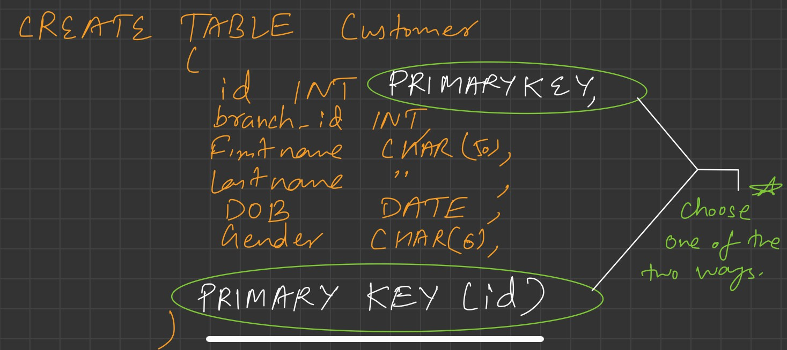

* 1. PK is not null, unique and only one per table.

CodeHelp

##### Foreign Key

* 1. FK refers to PK of other table.
  2. Each relation can having any number of FK.
  3. CREATE TABLE ORDER ( id INT PRIMARY KEY,

delivery_date DATE, order_placed_date DATE, cust_id INT,

FOREIGN KEY (cust_id) REFERENCES customer(id)

);

#### UNIQUE

* 1. Unique, can be null, table can have multiple unique aUributes.
  2. CREATE TABLE customer (

…

email VARCHAR(1024) UNIQUE,

…

);

#### CHECK

* 1. CREATE TABLE customer (

…

CONSTRAINT age_check CHECK (age > 12),

…

);

* 1. “age_check”, can also avoid this, MySQL generates name of constraint automatically.

#### DEFAULT

* 1. Set default value of the column.
  2. CREATE TABLE account (

…

saving-rate DOUBLE NOT NULL DEFAULT 4.25,

…

);

1. An aUribute can be **PK and FK both** in a table.

#### ALTER OPERATIONS

* 1. Changes schema

#### ADD

##### Add new column.

* + 1. ALTER TABLE table_name ADD new_col_name datatype ADD new_col_name_2 datatype;
    2. e.g., ALTER TABLE customer ADD age INT NOT NULL;

#### MODIFY

##### Change datatype of an aUribute.

* + 1. ALTER TABLE table-name MODIFY col-name col-datatype;
    2. E.g., VARCHAR TO CHAR

ALTER TABLE customer MODIFY name CHAR(1024);

#### CHANGE COLUMN

##### Rename column name.

* + 1. ALTER TABLE table-name CHANGE COLUMN old-col-name new-col-name new-col-datatype;
    2. e.g., ALTER TABLE customer CHANGE COLUMN name customer-name VARCHAR(1024);

CodeHelp

#### DROP COLUMN

##### Drop a column completely.

* + 1. ALTER TABLE table-name DROP COLUMN col-name;
    2. e.g., ALTER TABLE customer DROP COLUMN middle-name;

#### RENAME

##### Rename table name itself.

* + 1. ALTER TABLE table-name RENAME TO new-table-name;
    2. e.g., ALTER TABLE customer RENAME TO customer-details;

#### DATA MANIPULATION LANGUAGE (DML)

1. **INSERT**
   1. INSERT INTO table-name(col1, col2, col3) VALUES (v1, v2, v3), (val1, val2, val3);

#### UPDATE

* 1. UPDATE table-name SET col1 = 1, col2 = ‘abc’ WHERE id = 1;
  2. Update multiple rows e.g.,
     1. UPDATE student SET standard = standard + 1;

#### ON UPDATE CASCADE

* + 1. Can be added to the table while creating constraints. Suppose there is a situation where we have two tables such that primary key of one table is the foreign key for another table. if we update the primary key of the first table then using the ON UPDATE CASCADE foreign key of the second table automatically get updated.

#### DELETE

* 1. DELETE FROM table-name WHERE id = 1;
  2. DELETE FROM table-name; //all rows will be deleted.

##### DELETE CASCADE - (to overcome DELETE constraint of Referential constraints)

* + 1. What would happen to child entry if parent table’s entry is deleted?
    2. CREATE TABLE ORDER (

order_id int PRIMARY KEY, delivery_date DATE, cust_id INT,

FOREIGN KEY(cust_id) REFERENCES customer(id) ON DELETE CASCADE

);

##### ON DELETE NULL - (can FK have null values?)

* + - 1. CREATE TABLE ORDER (

order_id int PRIMARY KEY, delivery_date DATE, cust_id INT,

FOREIGN KEY(cust_id) REFERENCES customer(id) ON DELETE SET NULL

);

#### REPLACE

* + 1. Primarily used for already present tuple in a table.
    2. As UPDATE, using REPLACE with the help of WHERE clause in PK, then that row will be replaced.
    3. As INSERT, if there is no duplicate data new tuple will be inserted.
    4. REPLACE INTO student (id, class) VALUES(4, 3);
    5. REPLACE INTO table SET col1 = val1, col2 = val2;

#### JOINING TABLES

1. All **RDBMS** are relational in nature, we refer to other tables to get meaningful outcomes.
2. FK are used to do reference to other table.

#### INNER JOIN

* 1. Returns a resultant table that has matching values from both the tables or all the tables.
  2. 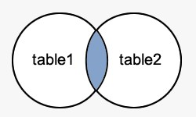SELECT column-list FROM table1 INNER JOIN table2 ON condition1 INNER JOIN table3 ON condition2

CodeHelp

…;

##### Alias in MySQL (AS)

* + 1. Aliases in MySQL is used to give a temporary name to a table or a column in a table for the purpose of

a particular query. It works as a nickname for expressing the tables or column names. It makes the query short and neat.

* + 1. SELECT col_name AS alias_name FROM table_name;
    2. SELECT col_name1, col_name2,... FROM table_name AS alias_name;

#### OUTER JOIN

* + - 1. **LEFT JOIN**
         1. 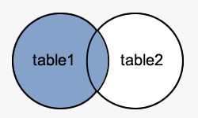This returns a resulting table that all the data from lei table and the matched data from the right table.
         2. SELECT columns FROM table LEFT JOIN table2 ON Join_Condition;

#### RIGHT JOIN

* + - * 1. 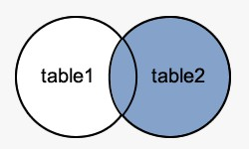This returns a resulting table that all the data from right table and the matched data from the lei table.
        2. SELECT columns FROM table RIGHT JOIN table2 ON join_cond;

#### FULL JOIN

* + - * 1. This returns a resulting table that contains all data when there is a match on lei or right table data.
        2. **Emulated** in MySQL using LEFT and RIGHT JOIN.
        3. 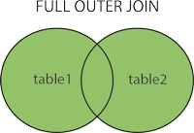LEFT JOIN UNION RIGHT JOIN.
        4. SELECT columns FROM table1 as t1 LEFT JOIN table2 as t2 ON t1.id = t2.id UNION

SELECT columns FROM table1 as t1 RIGHT JOIN table2 as t2 ON t1.id = t2.id;

* + - * 1. UNION ALL, can also be used this will duplicate values as well while UNION gives unique values.

#### CROSS JOIN

* + - 1. 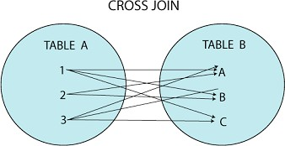This returns all the cartesian products of the data present in both tables. Hence, all possible variations are reflected in the output.
      2. Used rarely in practical purpose.
      3. Table-1 has 10 rows and table-2 has 5, then resultant would have 50 rows.
      4. SELECT column-lists FROM table1 CROSS JOIN table2;

#### SELF JOIN

* + - 1. It is used to get the output from a particular table when the same table is joined to itself.
      2. Used very less.
      3. Emulated using INNER JOIN.
      4. SELECT columns FROM table as t1 INNER JOIN table as t2 ON t1.id = t2.id;

##### Join without using join keywords.

* + - 1. SELECT * FROM table1, table2 WHERE condition;
      2. e.g., SELECT artist_name, album_name, year_recordedFROM artist, albumWHERE artist.id = album.artist_id;

#### SET OPERATIONS

1. Used to combine multiple select statements.
2. Always gives distinct rows.

|  |  |
| --- | --- |
| **JOIN** | **SET Operations** |
| Combines multiple tables based on matching condition. | Combination is resulting set from two or more SELECT statements. |
| Column wise combination. | Row wise combination. |
| Data types of two tables can be different. | Datatypes of corresponding columns from each table should be the same. |
| Can generate both distinct or duplicate rows. | Generate distinct rows. |
| The number of column(s) selected may or may not be the same from each table. | The number of column(s) selected must be the same from each table. |
| Combines results horizontally. | Combines results vertically. |

#### UNION

CodeHelp

* 1. Combines two or more SELECT statements.
  2. SELECT * FROM table1 UNION

SELECT * FROM table2;

* 1. Number of column, order of column must be same for table1 and table2.

#### INTERSECT

* 1. Returns common values of the tables.
  2. Emulated.
  3. SELECT DISTINCT column-list FROM table-1 INNER JOIN table-2 USING(join_cond);
  4. SELECT DISTINCT * FROM table1 INNER JOIN table2 ON USING(id);

#### MINUS

* 1. This operator returns the distinct row from the first table that does not occur in the second table.
  2. Emulated.
  3. SELECT column_list FROM table1 LEFT JOIN table2 ON condition WHERE table2.column_name IS NULL;
  4. e.g., SELECT id FROM table-1 LEFT JOIN table-2 USING(id) WHERE table-2.id IS NULL;

#### SUB QUERIES

1. 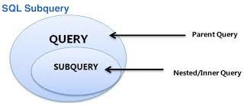Outer query depends on inner query.
2. Alternative to joins.
3. Nested queries.
4. SELECT column_list (s) FROM table_name WHERE column_name OPERATOR (SELECT column_list (s) FROM table_name [WHERE]);
5. e.g., SELECT * FROM table1 WHERE col1 IN (SELECT col1 FROM table1);
6. Sub queries exist mainly in 3 clauses
   1. Inside a WHERE clause.
   2. Inside a FROM clause.
   3. Inside a SELECT clause.

##### Subquery using FROM clause

* 1. SELECT MAX(rating) FROM (SELECT * FROM movie WHERE country = ‘India’) as temp;

##### Subquery using SELECT

* 1. SELECT (SELECT column_list(s) FROM T_name WHERE condition), columnList(s) FROM T2_name WHERE condition;

##### Derived Subquery

* 1. SELECT columnLists(s) FROM (SELECT columnLists(s) FROM table_name WHERE [condition]) as new_table_name;

##### Co-related sub-queries

* 1. 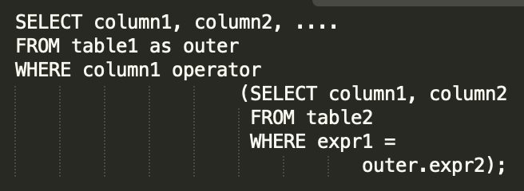With a normal nested subquery, the inner SELECT query runs first and executes once, returning values to be used by the main query. A correlated subquery, however, executes once for each candidate row considered by the outer query. In other words, the inner query is driven by the outer query.

#### JOIN VS SUB-QUERIES

CodeHelp

|  |  |
| --- | --- |
| **JOINS** | **SUBQUERIES** |
| Faster | Slower |
| Joins maximise calculation burden on DBMS | Keeps responsibility of calculation on user. |
| Complex, difficult to understand and implement | Comparatively easy to understand and implement. |
| Choosing optimal join for optimal use case is difficult | Easy. |

##### MySQL VIEWS

1. A view is a database object that has no values. Its contents are based on the base table. It contains rows and columns similar to the real table.
2. In MySQL, the View is a **virtual table** created by a query by joining one or more tables. It is operated similarly to the base table but does not contain any data of its own.
3. The View and table have one main difference that the views are definitions built on top of other tables (or views). If any changes occur in the underlying table, the same changes reflected in the View also.
4. CREATE VIEW view_name AS SELECT columns FROM tables [WHERE conditions];
5. ALTER VIEW view_name AS SELECT columns FROM table WHERE conditions;
6. DROP VIEW IF EXISTS view_name;
7. CREATE VIEW Trainer AS SELECT c.course_name, c.trainer, t.email FROM courses c, contact t WHERE c.id = t.id; (View using Join clause).

NOTE: We can also import/export table schema from files (.csv or json).

### LEC-11: Normalisation

1. **Normalisation** is a step towards DB optimisation.

##### Functional Dependency (FD)

* 1. It's a relationship between the primary key aUribute (usually) of the relation to that of the other aUribute of the relation.
  2. X -> Y, the lei side of FD is known as a **Determinant**, the right side of the production is known as a **Dependent**.

##### Types of FD

* + 1. **Trivial FD**
       1. A э B has trivial functional dependency if B is a subset of A. A->A, B->B are also Trivial FD.

##### Non-trivial FD

* + - * 1. A э B has a non-trivial functional dependency if B is not a subset of A. [A intersection B is NULL].

##### Rules of FD (Armstrong’s axioms)

* + 1. **Reflexive**
       1. If ‘A’ is a set of aUributes and ‘B’ is a subset of ‘A’. Then, Aэ B holds.
       2. If A ⊇ B then A э B.

##### Augmentation

* + - 1. If B can be determined from A, then adding an aUribute to this functional dependency won’t change anything.
      2. If Aэ B holds, then AXэ BX holds too. ‘X’ being a set of aUributes.

##### Transitivity

* + - * 1. If A determines B and B determines C, we can say that A determines C.
        2. if Aэ B and Bэ C then Aэ C.

CodeHelp

##### Why Normalisation?

To avoid redundancy in the DB, not to store redundant data.

##### What happen if we have redundant data?

Insertion, deletion and updation anomalies arises.

##### Anomalies

Anomalies means abnormalities, there are three types of anomalies introduced by data redundancy.

##### Insertion anomaly

When certain data (aUribute) can not be inserted into the DB without the presence of other data.

##### Deletion anomaly

The delete anomaly refers to the situation where the deletion of data results in the unintended loss of some other important data.

**Updation anomaly** (or modification anomaly)

The update anomaly is when an update of a single data value requires multiple rows of data to be updated.

Due to updation to many places, may be **Data inconsistency** arises, if one forgets to update the data at all the intended places.

Due to these anomalies, **DB size increases** and **DB performance become very slow.**

To rectify these anomalies and the effect of these of DB, we use **Database optimisation technique** called

#### NORMALISATION.

##### What is Normalisation?

Normalisation is used to minimise the redundancy from a relations. It is also used to eliminate undesirable characteristics like Insertion, Update, and Deletion Anomalies.

Normalisation divides the composite aUributes into individual aUributes OR larger table into smaller and links them using relationships.

The normal form is used to reduce redundancy from the database table.

* + - * 1. **Types of Normal forms**

#### 1NF

Every relation cell must have atomic value.

Relation must not have multi-valued aUributes.

#### 2NF

Relation must be in 1NF.

There should not be any partial dependency.

All non-prime aUributes must be fully dependent on PK.

Non prime aUribute can not depend on the part of the PK.

#### 3NF

Relation must be in 2NF.

No transitivity dependency exists.

**1.** Non-prime aUribute should not find a non-prime aUribute.

##### BCNF (Boyce-Codd normal form)

Relation must be in 3NF.

FD: A -> B, A must be a super key.

**1.** We must not derive prime aUribute from any prime or non-prime aUribute.

##### Advantages of Normalisation

Normalisation helps to minimise data redundancy.

Greater overall database organisation.

Data consistency is maintained in DB.

CodeHelp

### LEC-12: Transaction

##### Transaction

* 1. A unit of work done against the DB in a logical sequence.
  2. Sequence is very important in transaction.
  3. It is a logical unit of work that contains one or more SQL statements. The result of all these statements in a transaction either gets completed successfully (all the changes made to the database are permanent) or if at any point any failure happens it gets rollbacked (all the changes being done are undone.)

##### ACID Properties

* 1. To ensure integrity of the data, we require that the DB system maintain the following properties of the transaction.

##### Atomicity

* + 1. Either all operations of transaction are reflected properly in the DB, or none are.

##### Consistency

* + 1. Integrity constraints must be maintained before and aier transaction.
    2. DB must be consistent aier transaction happens.

##### Isolation

* + 1. Even though multiple transactions may execute concurrently, the system guarantees that, for every pair of transactions Ti and Tj, it appears to Ti that either Tj finished execution before Ti started, or Tj started execution aier Ti finished. Thus, each transaction is unaware of other transactions executing concurrently in the system.
    2. Multiple transactions can happen in the system in isolation, without interfering each other.

##### Durability

* + 1. Aier transaction completes successfully, the changes it has made to the database persist, even if there are system failures.

CodeHelp

##### Transaction states

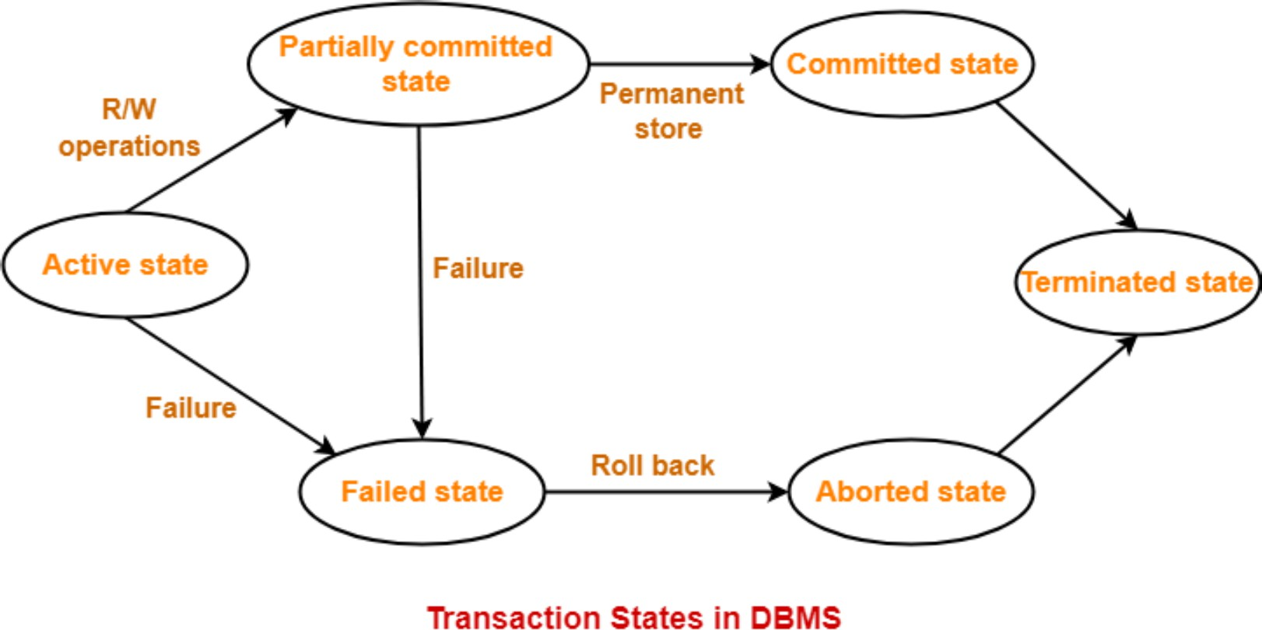

* 1. **Active state**
     1. The very first state of the life cycle of the transaction, all the read and write operations are being performed. If they execute without any error the T comes to Partially commiUed state. Although if any error occurs then it leads to a Failed state.

##### Partially commiUed state

* + - 1. Aier transaction is executed the changes are saved in the buffer in the main memory. If the changes made are permanent on the DB then the state will transfer to the commiUed state and if there is any failure, the T will go to Failed state.

##### CommiUed state

CodeHelp

* + - 1. When updates are made permanent on the DB. Then the T is said to be in the commiUed state. Rollback can’t be done from the commiUed states. New consistent state is achieved at this stage.

##### Failed state

* + - 1. When T is being executed and some failure occurs. Due to this it is impossible to continue the execution of the T.

##### Aborted state

* + - 1. When T reaches the failed state, all the changes made in the buffer are reversed. Aier that the T rollback completely. T reaches abort state aier rollback. DB’s state prior to the T is achieved.

##### Terminated state

* + - 1. A transaction is said to have terminated if has either commiUed or aborted.

### LEC-13: How to implement Atomicity and Durability in Transactions

1. **Recovery Mechanism Component** of DBMS supports **atomicity and durability.**
2. **Shadow-copy scheme**
   1. Based on making copies of DB (aka, **shadow copies)**.
   2. Assumption only one Transaction (T) is active at a time.
   3. A pointer called **db-pointer** is maintained on the **disk**; which at any instant points to current copy of DB.
   4. T, that wants to update DB first creates a complete copy of DB.
   5. All further updates are done on new DB copy leaving the original copy (shadow copy) untouched.
   6. If at any point the **T has to be aborted** the system deletes the new copy. And the old copy is not affected.
   7. If T success, it is commiUed as,
      1. OS makes sure all the pages of the new copy of DB wriUen on the disk.
      2. DB system updates the db-pointer to point to the new copy of DB.
      3. New copy is now the current copy of DB.
      4. The old copy is deleted.
      5. The T is said to have been **COMMITTED** at the point where the updated db-pointer is wriUen to disk.
   8. **Atomicity**
      1. If T fails at any time before db-pointer is updated, the old content of DB are not affected.
      2. T abort can be done by just deleting the new copy of DB.
      3. Hence, either all updates are reflected or none.
   9. **Durability**
      1. Suppose, system fails are any time before the updated db-pointer is wriUen to disk.
      2. When the system restarts, it will read db-pointer G will thus, see the original content of DB and none of the effects of T will be visible.
      3. T is assumed to be successful only when db-pointer is updated.
      4. If **system fails after** db-pointer has been updated. Before that all the pages of the new copy were wriUen to disk. Hence, when system restarts, it will read new DB copy.

CodeHelp

* 1. The implementation is dependent on write to the db-pointer being atomic. Luckily, disk system provide atomic updates to entire block or at least a disk sector. So, we make sure db-pointer lies entirely in a single sector. By storing db-pointer at the beginning of a block.
  2. **Ineﬃcient**, as entire DB is copied for every Transaction.

1. **Log-based recovery methods**
   1. The log is a sequence of records. Log of each transaction is maintained in some **stable storage** so that if any failure occurs, then it can be recovered from there.
   2. If any operation is performed on the database, then it will be recorded in the log.
   3. But the process of storing the logs should be done **before** the actual transaction is applied in the database.
   4. **Stable storage** is a classification of computer data storage technology that guarantees atomicity for any given write operation and allows soiware to be wriUen that is robust against some hardware and power failures.
   5. **Deferred DB Modifications**
      1. Ensuring **atomicity** by recording all the DB modifications in the log but deferring the execution of all the write operations until the final action of the T has been executed.
      2. Log information is used to execute deferred writes when T is completed.
      3. If system crashed before the T completes, or if T is aborted, the information in the logs are ignored.
      4. If T completes, the records associated to it in the log file are used in executing the deferred writes.
      5. If failure occur while this updating is taking place, we preform redo.
   6. **Immediate DB Modifications**
      1. DB modifications to be output to the DB while the T is still in active state.
      2. DB modifications wriUen by active T are called uncommiUed modifications.
      3. In the event of crash or T failure, system uses old value field of the log records to restore modified values.
      4. Update takes place only aier log records in a stable storage.
      5. Failure handling
         1. System failure before T completes, or if T aborted, then old value field is used to undo the T.
         2. If T completes and system crashes, then new value field is used to redo T having commit logs in the logs.

### LEC-14: Indexing in DBMS

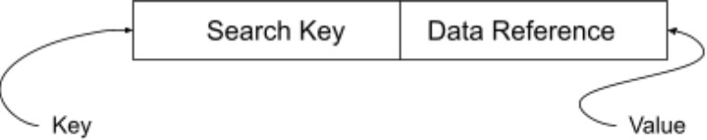

1. **Indexing** is used to **optimise the performance** of a database by minimising the number of disk accesses required when a query is processed.
2. The index is a type of **data structure.** It is used to locate and access the data in a database table quickly.
3. **Speeds up operation** with read operations like **SELECT** queries, **WHERE** clause etc.
4. **Search Key**: Contains copy of primary key or candidate key of the table or something else.
5. **Data Reference**: Pointer holding the address of disk block where the value of the corresponding key is stored.
6. Indexing is **optional**, but increases access speed. It is not the primary mean to access the tuple, it is the secondary mean.
7. **Index file is always sorted.**
8. **Indexing Methods**
   1. **Primary Index (Clustering Index)**
      1. A file may have several indices, on different search keys. If the data file containing the records is sequentially ordered, a Primary index is an index whose search key also defines the sequential order of the file.
      2. **NOTE**: The term primary index is sometimes used to mean an index on a primary key. However, such usage is

**nonstandard** and **should be avoided.**

* + 1. All files are ordered sequentially on some search key. It could be Primary Key or non-primary key.
    2. **Dense And Sparse Indices**
       1. **Dense Index**
          1. The dense index contains an index record for every search key value in the data file.
          2. The index record contains the search-key value and a pointer to the first data record with that search-key value.

The rest of the records with the same search-key value would be stored sequentially aier the first record.

* + - * 1. It needs more space to store index record itself. The index records have the search key and a pointer to the actual record on the disk.

CodeHelp

* + - 1. **Sparse Index**
         1. An index record appears for only some of the search-key values.
         2. Sparse Index helps you to resolve the issues of dense Indexing in DBMS. In this method of indexing technique, a range of index columns stores the same data block address, and when data needs to be retrieved, the block address will be fetched.
    1. Primary Indexing can be based on Data file is sorted w.r.t Primary Key aUribute or non-key aUributes.
    2. **Based on Key aUribute**
       1. Data file is sorted w.r.t primary key aUribute.
       2. PK will be used as search-key in Index.
       3. Sparse Index will be formed i.e., no. of entries in the index file = no. of blocks in datafile.
    3. **Based on Non-Key aUribute**
       1. Data file is sorted w.r.t non-key aUribute.
       2. No. Of entries in the index = unique non-key aUribute value in the data file.
       3. This is dense index as, all the unique values have an entry in the index file.

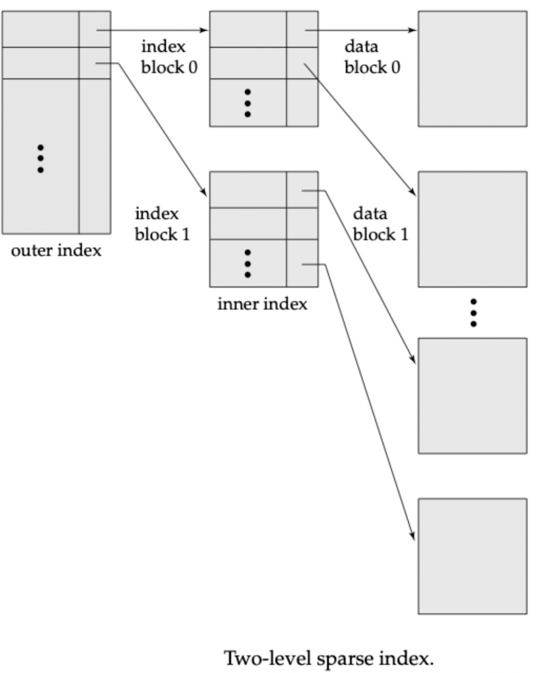

* + - 1. E.g., Let’s assume that a company recruited many employees in various departments. In this case, clustering indexing in DBMS should be created for all employees who belong to the same dept.
    1. **Multi-level Index**
       1. Index with two or more levels.
       2. If the single level index become enough large that the binary search it self would take much time, we can break down indexing into multiple levels.
  1. **Secondary Index (Non-Clustering Index)**
     1. Datafile is unsorted. Hence, Primary Indexing is not possible.
     2. Can be done on key or non-key aUribute.
     3. Called secondary indexing because normally one indexing is already applied.
     4. No. Of entries in the index file = no. of records in the data file.
     5. It's an example of Dense index.

CodeHelp

1. **Advantages of Indexing**
   1. Faster access and retrieval of data.
   2. IO is less.
2. **Limitations of Indexing**
   1. Additional space to store index table
   2. Indexing Decrease performance in INSERT, DELETE, and UPDATE query.

### LEC-15: NoSQL

1. **NoSQL databases** (aka "not only SQL") are non-tabular databases and store data differently than relational tables. NoSQL databases come in a variety of types based on their data model. The main types are document, key-value, wide-column, and graph. They provide **flexible schemas** and **scale** easily with **large amounts of data** and **high user loads**.
   1. They are schema free.
   2. Data structures used are not tabular, they are more flexible, has the ability to adjust dynamically.
   3. Can handle huge amount of data **(big data).**
   4. Most of the NoSQL are open sources and has the capability of horizontal scaling.
   5. **It just stores data in some format other than relational.**
2. **History behind NoSQL**
   1. NoSQL databases emerged in the late 2000s as the cost of storage dramatically decreased. Gone were the days of needing to create a complex, diﬃcult-to-manage data model in order to avoid data duplication. Developers (rather than storage) were becoming the primary cost of soiware development, so NoSQL databases optimised for developer productivity.
   2. Data becoming unstructured more, hence structuring (defining schema in advance) them had becoming costly.
   3. NoSQL databases allow developers to store huge amounts of unstructured data, giving them a lot of flexibility.
   4. Recognising the need to rapidly adapt to changing requirements in a soiware system. Developers needed the ability to iterate quickly and make changes throughout their soiware stack — all the way down to the database. NoSQL databases gave them this flexibility.
   5. Cloud computing also rose in popularity, and developers began using public clouds to host their applications and data. They wanted the ability to distribute data across multiple servers and regions to make their applications resilient, to scale out instead of scale up, and to intelligently geo-place their data. Some NoSQL databases like MongoDB provide these capabilities.
3. **NoSQL Databases Advantages**
4. **Flexible Schema**
   1. RDBMS has pre-defined schema, which become an issue when we do not have all the data with us or we need to change the schema. It's a huge task to change schema on the go.

CodeHelp

1. **Horizontal Scaling**
   1. Horizontal scaling, also known as scale-out, refers to bringing on additional nodes to share the load. This is diﬃcult with relational databases due to the diﬃculty in spreading out related data across nodes. With non-relational databases, this is made simpler since collections are self-contained and not coupled relationally. This allows them to be distributed across nodes more simply, as queries do not have to “join” them together across nodes.
   2. Scaling horizontally is achieved through **Sharding** OR **Replica-sets**.
2. **High Availability**
   1. NoSQL databases are highly available due to its auto replication feature i.e. whenever any kind of failure happens data replicates itself to the preceding consistent state.
   2. If a server fails, we can access that data from another server as well, as in NoSQL database data is stored at multiple servers.
3. **Easy insert and read operations.**
   1. Queries in NoSQL databases can be faster than SQL databases. Why? Data in SQL databases is typically normalised, so queries for a single object or entity require you to join data from multiple tables. As your tables grow in size, the joins can become expensive. However, data in NoSQL databases is typically stored in a way that is optimised for queries. The rule of thumb when you use MongoDB is data that is accessed together should be stored together. Queries typically do not require joins, so the queries are very fast.
   2. But diﬃcult delete or update operations.
4. **Caching** mechanism**.**
5. **NoSQL** use case is more for **Cloud** applications.
6. **When to use NoSQL?**
   1. Fast-paced Agile development
   2. Storage of structured and semi-structured data
   3. Huge volumes of data
   4. Requirements for scale-out architecture
   5. Modern application paradigms like micro-services and real-time streaming.
7. **NoSQL DB Misconceptions**
   1. Relationship data is best suited for relational databases.
      1. A common misconception is that NoSQL databases or non-relational databases don’t store relationship data well. NoSQL databases can store relationship data — they just store it differently than relational databases do. In fact, when compared with relational databases, many find modelling relationship data in NoSQL databases to be easier than in relational databases, because related data doesn’t have to be split between tables. NoSQL data models allow related data to be nested within a single data structure.
      2. NoSQL databases don't support ACID transactions.
         1. Another common misconception is that NoSQL databases don't support ACID transactions. Some NoSQL databases like MongoDB do, in fact, support ACID transactions.
8. **Types of NoSQL Data Models**
   1. **Key-Value Stores**
      1. The simplest type of NoSQL database is a key-value store. Every data element in the database is stored as a key value pair consisting of an aUribute name (or "key") and a value. In a sense, a key-value store is like a relational database with only two columns: the key or aUribute name (such as "state") and the value (such as "Alaska").
      2. **Use cases** include shopping carts, user preferences, and user profiles.
      3. e.g., Oracle NoSQL, Amazon DynamoDB, MongoDB also supports Key-Value store, Redis.
      4. A key-value database associates a value (which can be anything from a number or simple string to a complex object) with a key, which is used to keep track of the object. In its simplest form, a key-value store is like a dictionary/array/map object as it exists in most programming paradigms, but which is stored in a persistent way and managed by a Database Management System (DBMS).
      5. Key-value databases use compact, eﬃcient index structures to be able to quickly and reliably locate a value by its key, making them ideal for systems that need to be able to find and retrieve data in constant time.
      6. There are several use-cases where choosing a key value store approach is an optimal solution:
9. Real time random data access, e.g., user session aUributes in an online application such as gaming or finance.
10. Caching mechanism for frequently accessed data or configuration based on keys.
11. Application is designed on simple key-based queries.
    1. **Column-Oriented / Columnar / C-Store / Wide-Column**
       1. The data is stored such that each row of a column will be next to other rows from that same column.
       2. While a relational database stores data in rows and reads data row by row, a column store is organised as a set of columns. This means that when you want to run analytics on a small number of columns, you can read those columns directly without consuming memory with the unwanted data. Columns are oien of the same type and benefit from more eﬃcient compression, making reads even faster. Columnar databases can quickly aggregate the value of a given column (adding up the total sales for the year, for example). **Use cases** include analytics.

CodeHelp

* + 1. e.g., Cassandra, RedShii, Snowflake.
  1. **Document Based Stores**
     1. This DB store data in documents similar to JSON (JavaScript Object Notation) objects. Each document contains pairs of fields and values. The values can typically be a variety of types including things like strings, numbers, booleans, arrays, or objects.
     2. **Use cases** include e-commerce platforms, trading platforms, and mobile app development across industries.
     3. Supports ACID properties hence, suitable for Transactions.
     4. e.g., MongoDB, CouchDB.
  2. **Graph Based Stores**
     1. A graph database focuses on the relationship between data elements. Each element is stored as a node (such as a person in a social media graph). The connections between elements are called links or relationships. In a graph database, connections are first-class elements of the database, stored directly. In relational databases, links are implied, using data to express the relationships.
     2. A graph database is optimised to capture and search the connections between data elements, overcoming the overhead associated with JOINing multiple tables in SQL.
     3. Very few real-world business systems can survive solely on graph queries. As a result graph databases are usually run alongside other more traditional databases.
     4. **Use cases** include fraud detection, social networks, and knowledge graphs.

1. **NoSQL Databases Dis-advantages**
   1. **Data Redundancy**
      1. Since data models in NoSQL databases are typically optimised for queries and not for reducing data duplication, NoSQL databases can be larger than SQL databases. Storage is currently so cheap that most consider this a minor drawback, and some NoSQL databases also support compression to reduce the storage footprint.
      2. Update G Delete operations are **costly**.
      3. All type of NoSQL Data model doesn’t fulfil all of your application needs
         1. Depending on the NoSQL database type you select, you may not be able to achieve all of your use cases in a single database. For example, graph databases are excellent for analysing relationships in your data but may not provide what you need for everyday retrieval of the data such as range queries. When selecting a NoSQL database, consider what your use cases will be and if a general purpose database like MongoDB would be a beUer option.
      4. Doesn’t support ACID properties in general.
      5. Doesn’t support data entry with consistency constraints.

CodeHelp

1. **SQL vs NoSQL**

|  |  |  |
| --- | --- | --- |
|  | **SQL Databases** | **NoSQL Databases** |
| **Data Storage Model** | Tables with fixed rows and columns | Document: JSON documents, Key-value: key-value pairs, Wide- column: tables with rows and dynamic columns, Graph: nodes and edges |
| **Development History** | Developed in the 1970s with a focus on reducing data duplication | Developed in the late 2000s with a focus on scaling and allowing for rapid application change driven by agile and DevOps practices. |
| **Examples** | Oracle, MySQL, Microsoft SQL Server, and PostgreSQL | Document: MongoDB and CouchDB, Key-value: Redis and DynamoDB, Wide-column: Cassandra and HBase, Graph: Neo4j and Amazon Neptune |
| **Primary Purpose** | General Purpose | Document: general purpose, Key- value: large amounts of data with simple lookup queries, Wide- column: large amounts of data with predictable query patterns, Graph: analyzing and traversing relationships between connected data |
| **Schemas** | Fixed | Flexible |
| **Scaling** | Vertical (Scale-up) | Horizontal (scale-out across commodity servers) |
| **ACID Properties** | Supported | Not Supported, except in DB like MongoDB etc. |
| **JOINS** | Typically Required | Typically not required |
| **Data to object mapping** | Required object-relational mapping | Many do not require ORMs. MongoDB documents map directly to data structures in most popular programming languages. |

### LEC-16: Types of Databases

1. **Relational Databases**
   1. Based on Relational Model.
   2. Relational databases are quite **popular**, even though it was a system designed in the 1970s. Also known as relational database management systems (RDBMS), relational databases commonly use **Structured Query Language (SQL)** for operations such as **creating**, **reading**, **updating**, and **deleting** data. Relational databases store information in **discrete tables**, which can be **JOIN**ed together by fields known as **foreign** keys. For example, you might have a User table which contains information about all your users, and **join** it to a Purchases table, which contains information about all the purchases they’ve made. MySQL, Microsoi SQL Server, and Oracle are types of relational databases.
   3. they are ubiquitous, having acquired a steady user base since the 1970s
   4. they are highly optimised for working with structured data.
   5. they provide a stronger guarantee of data normalisation
   6. they use a well-known querying language through SQL
   7. **Scalability issues** (Horizontal Scaling).
   8. Data become huge, system become more complex.
2. **Object Oriented Databases**
   1. The object-oriented data model, is based on the **object-oriented-programming paradigm,** which is now in wide use. **Inheritance**, **object**-**identity**, and **encapsulation** (information hiding), with methods to provide an interface to objects, are among the key concepts of object-oriented programming that have found applications in data modelling. The object-oriented data model also supports a rich type system, including structured and collection types. While inheritance and, to some extent, complex types are also present in the E-R model, encapsulation and object-identity distinguish the object-oriented data model from the E-R model.
   2. Sometimes the database can be very complex, having multiple relations. So, maintaining a relationship between them can be tedious at times.
      1. In Object-oriented databases data is treated as an object.

CodeHelp

* + 1. All bits of information come in one instantly available object package instead of multiple tables.

1. **Advantages**
   1. Data storage and retrieval is easy and quick.
   2. Can handle complex data relations and more variety of data types that standard relational databases.
   3. Relatively friendly to model the advance real world problems
   4. Works with functionality of OOPs and Object Oriented languages.
2. **Disadvantages**
   1. High complexity causes performance issues like read, write, update and delete operations are slowed down.
   2. Not much of a community support as isn’t widely adopted as relational databases.
   3. Does not support views like relational databases.
3. e.g., ObjectDB, GemStone etc.
4. **NoSQL Databases**
   1. NoSQL databases (aka "not only SQL") are non-tabular databases and store data differently than relational tables. NoSQL databases come in a variety of types based on their data model. The main types are document, key-value, wide-column, and graph. They provide flexible schemas and scale easily with large amounts of data and high user loads.
   2. They are schema free.
   3. Data structures used are not tabular, they are more flexible, has the ability to adjust dynamically.
   4. Can handle huge amount of data (big data).
   5. Most of the NoSQL are open sources and has the capability of horizontal scaling.
   6. It just stores data in some format other than relational.
   7. Refer **LEC-15** notes…
5. **Hierarchical Databases**
   1. As the name suggests, the hierarchical database model is most appropriate for use cases in which the main focus of information gathering is based on a **concrete hierarchy**, such as several individual employees reporting to a single department at a company.
   2. The schema for hierarchical databases is defined by its **tree-like** organisation, in which there is typically a **root** “parent” directory of data stored as records that links to various other subdirectory branches, and each subdirectory branch, or child record, may link to various other subdirectory branches.
   3. The hierarchical database structure dictates that, while a parent record can have several child records, each child record can only have **one parent** record. Data within records is stored in the form of fields, and each field can only contain one value. Retrieving hierarchical data from a hierarchical database architecture requires traversing the entire tree, starting at the root node.
   4. Since the **disk storage system** is also inherently a hierarchical structure, these models can also be used as physical models.
   5. The key **advantage** of a hierarchical database is its ease of use. The one-to-many organisation of data makes traversing the database simple and fast, which is ideal for use cases such as website drop-down menus or computer folders in systems like

Microsoi Windows OS. Due to the separation of the tables from physical storage structures, information can easily be added or deleted without affecting the entirety of the database. And most major programming languages offer functionality for reading tree structure databases.

* 1. The major **disadvantage** of hierarchical databases is their inflexible nature. The one-to-many structure is not ideal for complex structures as it cannot describe relationships in which each child node has multiple parents nodes. Also the tree-like organisation of data requires top-to-boUom sequential searching, which is time consuming, and requires repetitive storage of data in multiple different entities, which can be redundant.
  2. e.g., IBM IMS.

1. **Network Databases**
   1. **Extension** of Hierarchical databases
   2. The child records are given the freedom to associate with multiple parent records.
   3. 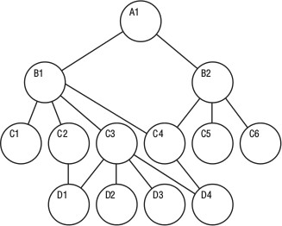Organised in a **Graph** structure.
   4. Can handle complex relations.
   5. Maintenance is tedious.
   6. **M:N links** may cause slow retrieval.
   7. Not much web community support.
   8. e.g., Integrated Data Store (IDS), IDMS (Integrated Database Management System), Raima Database Manager, TurboIMAGE etc.

CodeHelp

### LEC-17: Clustering in DBMS

1. **Database Clustering** (making **Replica-sets**) is the process of combining more than one servers or instances connecting a single database. Sometimes one server may not be adequate to manage the amount of data or the number of requests, that is when a Data Cluster is needed. Database clustering, SQL server clustering, and SQL clustering are closely associated with SQL is the language used to manage the database information.
2. Replicate the same dataset on different servers.
3. **Advantages**
   1. **Data Redundancy:** Clustering of databases helps with data redundancy, as we store the same data at multiple servers. Don’t confuse this data redundancy as repetition of the same data that might lead to some anomalies. The redundancy that clustering offers is required and is quite certain due to the synchronisation. In case any of the servers had to face a failure due to any possible reason, the data is available at other servers to access.
   2. **Load balancing:** or scalability doesn’t come by default with the database. It has to be brought by clustering regularly. It also depends on the setup. Basically, what load balancing does is allocating the workload among the different servers that are part of the cluster. This indicates that more users can be supported and if for some reasons if a huge spike in the traffic appears, there is a higher assurance that it will be able to support the new traffic. One machine is not going to get all of the hits. This can provide **scaling** seamlessly as required. This **links directly to high availability.** Without load balancing, a particular machine could get overworked and traffic would slow down, leading to decrement of the traffic to zero.
   3. **High availability:** When you can access a database, it implies that it is available. High availability refers the amount of time a database is considered available. The amount of availability you need greatly depends on the number of transactions you are running on your database and how often you are running any kind of analytics on your data. With database clustering, we can reach extremely high levels of availability due to load balancing and have extra machines. In case a server got shut down the database will, however, be available.
   4. **How does Clustering Work?**
      1. In cluster architecture, all requests are split with many computers so that an individual user request is executed and produced by a number of computer systems. The clustering is serviceable definitely by the ability of load balancing and high-availability. If one node collapses, the request is handled by another node. Consequently, there are few or no possibilities of absolute system failures.

CodeHelp

### LEC-18: Partitioning & Sharding in DBMS (DB Optimisation)

1. **A big problem** can be solved easily when it is chopped into several smaller sub-problems. That is what the partitioning technique does. It divides a big database containing data metrics and indexes into smaller and handy slices of data called partitions. The partitioned tables are directly used by SQL queries without any alteration. Once the database is partitioned, the data definition language can easily work on the smaller partitioned slices, instead of handling the giant database altogether. This is how partitioning cuts down the problems in managing large database tables.
2. **Partitioning** is the technique used to divide stored database objects into separate servers. Due to this, there is an increase in performance, controllability of the data. We can manage huge chunks of data optimally. When we horizontally scale our machines/servers, we know that it gives us a challenging time dealing with relational databases as it’s quite tough to maintain the relations. But if we apply partitioning to the database that is already scaled out i.e. equipped with multiple servers, we can partition our database among those servers and handle the big data easily.
3. **Vertical Partitioning**
   1. Slicing relation vertically / column-wise.
   2. Need to access different servers to get complete tuples.
4. **Horizontal Partitioning**
   1. Slicing relation horizontally / row-wise.
   2. Independent chunks of data tuples are stored in different servers.
5. **When Partitioning is Applied?**
   1. Dataset become much huge that managing and dealing with it become a tedious task.
   2. The number of requests are enough larger that the single DB server access is taking huge time and hence the system’s response time become high.
6. **Advantages of Partitioning**
   1. Parallelism
   2. Availability
   3. Performance
   4. Manageability
   5. Reduce Cost, as scaling-up or vertical scaling might be costly.

CodeHelp

1. **Distributed Database**
   1. A single logical database that is, spread across multiple locations (servers) and logically interconnected by network.
   2. This is the product of applying DB optimisation techniques like **Clustering, Partitioning and Sharding.**
   3. Why this is needed? READ Point **5**.
2. **Sharding**
   1. Technique to implement Horizontal Partitioning.
   2. The **fundamental idea** of Sharding is the idea that instead of having all the data sit on one DB instance, we split it up and introduce a Routing layer so that we can forward the request to the right instances that actually contain the data.
   3. **Pros**
      1. Scalability
      2. Availability
   4. **Cons**
      1. Complexity, making partition mapping, Routing layer to be implemented in the system, Non-uniformity that creates the necessity of Re- Sharding
      2. Not well suited for Analytical type of queries, as the data is spread across different DB instances. (Scatter-Gather problem)



**Database Scaling Patterns**

CodeHelp

## Step by Step Scaling

**- Lakshay**

# What will you learn?

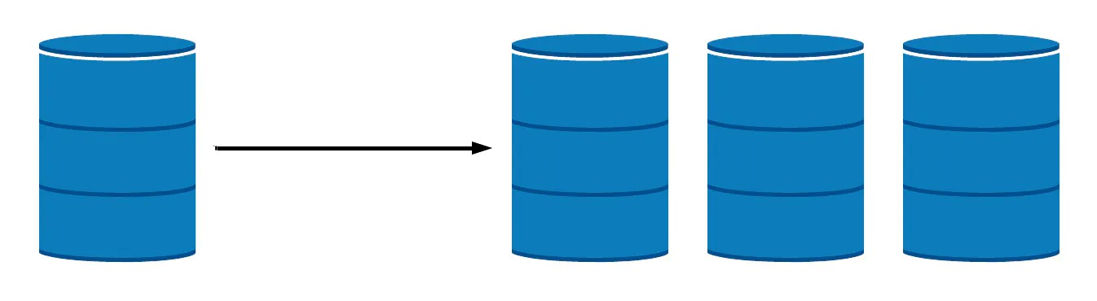

* Step by Step manner, when to choose which Scaling option.
* Which Scaling option is feasible practically at the moment.

CodeHelp

# A Case Study



## Cab Booking APP

* Tiny startup.
* ~10 customers onboard.

CodeHelp

* A single small machine DB stores all customers, trips, locations, booking data, and customer trip history.
* ~1 trip booking in 5 mins.

# Your App becoming famous, but…



## The PROBLEM begins

* Requests scales upto 30 bookings per minute.
* Your tiny DB system has started performing poorly.

CodeHelp

* API latency has increased a lot.
* Transactions facing Deadlock, Starvation, and frequent failure.
* Sluggish App experience.
* Customer dis-satisfaction.

# Is there any solution?



* We have to apply some kind of performance optimisation measures.
* We might have to scale our system going forward.

CodeHelp

# Pattern 1



## Query Optimisation & Connection Pool Implementation

* Cache frequently used non-dynamic data like, booking history, payment history, user profiles etc.

CodeHelp

* Introduce Database Redundancy. (Or may be use NoSQL)
* Use connection pool libraries to **Cache DB connections**.
* Multiple application threads can use same DB connection.
* Good optimisations as of now.
* Scaled the business to one more city, and now getting ~100 booking per minute.

# Pattern 2



## Vertical Scaling or Scale-up

* Upgrading our initial tiny machine.
* RAM by 2x and SSD by 3x etc.

CodeHelp

* Scale up is pocket friendly till a point only.
* More you scale up, cost increases exponentially.
* Good Optimisation as of now.
* Business is growing, you decided to scale it to 3 more cities and now getting 300 booking per minute.

# Pattern 3



## Command Query Responsibility Segregation (CQRS)

* The scaled up big machine is not able to handle all read/write requests.
* Separate read/write operations physical machine wise.

CodeHelp

* 2 more machines as replica to the primary machine.
* All read queries to replicas.
* All write queries to primary.
* Business is growing, you decided to scale it to 2 more cities.
* Primary is not able to handle all write requests.
* Lag between primary and replica is impacting user experience.

# Pattern 4



## Multi Primary Replication

* Why not distribute write request to replica also?
* All machines can work as primary & replica.

CodeHelp

* Multi primary configuration is a logical circular ring.
* Write data to any node.
* Read data from any node that replies to the broadcast first.
* You scale to 5 more cities & your system is in pain again. (~50 req/s)

# Pattern 5



## Partitioning of Data by Functionality

* What about separating the location tables in separate DB schema?
* What about putting that DB in separate machines with primary-replica or multi-primary configuration?

CodeHelp

* Different DB can host data categorised by different functionality.
* Backend or application layer has to take responsibility to join the results.
* Planning to expand your business to other country.

# Pattern 6



## Horizontal Scaling or Scale-out

* Sharding - multiple shards.
* Allocate 50 machines - all having same DB schema - each machine just hold a part of data.

CodeHelp

* Locality of data should be there.
* Each machine can have their own replicas, may be used in failure recovery.
* Sharding is generally hard to apply. But “No Pain, No Gain”
* Scaling the business across continents.

# Pattern 7



## Data Centre Wise Partition

* Requests travelling across continents are having high latency.
* What about distributing traffic across data centres?

CodeHelp

* Data centres across continents.
* Enable cross data centre replication which helps disaster recovery.
* This always maintain Availability of your system.
* Now, Plan for an IPO :p



***lakshaykumar***

*2022-10-16 20:28:57*

--------------------------------------------

RDBMS databases are often at the CA side of the triangle. This is only the case in a single node setup. Even with master (write) - slave (read) setup, the system is not CA (or if it is termed "CA" for some reason, and cannot recover from network partitions, then a split-bran scenario may happen, a new master is elected for the partition, and chaos ensues, possibly breaking the consistency of the system).

### LEC-20: CAP Theorem

1. Basic and one of the most important concept in **Distributed Databases.**
2. **Useful** to know this to design efficient distributed system for your given business logic.
3. Let’s first breakdown CAP
   1. **Consistency**: In a consistent system, all nodes see the same data simultaneously. If we perform a read operation on a consistent system, it should return the value of the most recent write operation. The read should cause all nodes to return the same data. All users see the same data at the same time, regardless of the node they connect to. When data is written to a single node, it is then replicated across the other nodes in the system.
   2. **Availability**: When availability is present in a distributed system, it means that the system remains operational all of the time. Every request will get a response regardless of the individual state of the nodes. This means that the system will operate even if there are multiple nodes down. Unlike a consistent system, there’s no guarantee that the response will be the most recent write operation.
   3. **Partition Tolerance**: When a distributed system encounters a partition, it means that there’s a break in communication between nodes. If a system is partition-tolerant, the system does not fail, regardless of whether messages are dropped or delayed between nodes within the system. To have partition tolerance, the system must replicate records across combinations of nodes and networks.
   4. What does the **CAP Theorem** says,
      1. The CAP theorem states that a distributed system can only provide **two of three properties** simultaneously: consistency, availability, and partition tolerance. The theorem formalises the **tradeoff between consistency and availability when there’s a partition.**
   5. **CAP Theorem NoSQL Databases:** NoSQL databases are great for distributed networks. They allow for horizontal scaling, and they can quickly scale across multiple nodes. When deciding which NoSQL database to use, it’s important to keep the CAP theorem in mind.
      1. **CA Databases:** CA databases enable consistency and availability across all nodes. Unfortunately, CA databases can’t deliver fault tolerance. In any distributed system, partitions are bound to happen, which means this type of database isn’t a very practical choice. That being said, you still can find a CA database if you need one. Some relational databases, such as MySQL or PostgreSQL, allow for consistency and availability. You can deploy them to nodes using replication.
      2. **CP Databases:** CP databases enable consistency and partition tolerance, but not availability. When a partition occurs, the system has to turn off inconsistent nodes until the partition can be fixed. MongoDB is an example of a CP database. It’s a NoSQL database management system (DBMS) that uses documents for data storage. It’s considered schema-less, which means that it doesn’t require a defined database schema. It’s commonly used in big data and applications running in different locations. The CP system is structured so that there’s **only one primary node that receives all of the write requests in a given replica set.** Secondary nodes replicate the data in the primary nodes, so if the primary node fails, a secondary node can stand-in. In banking system Availability is not as important as consistency, so we can opt it (MongoDB).

CodeHelp

* + 1. **AP Databases:** AP databases enable availability and partition tolerance, but not consistency. In the event of a partition, all nodes are available, but they’re not all updated. For example, if a user tries to access data from a bad node, they won’t receive the most up-to-date version of the data. When the partition is eventually resolved, most AP databases will sync the nodes to ensure consistency across them. Apache Cassandra is an example of an AP database. It’s a NoSQL database with no primary node, meaning that all of the nodes remain available. Cassandra allows for eventual consistency because users can re-sync their data right after a partition is resolved. For apps like Facebook, we value availability more than consistency, we’d opt for AP Databases like Cassandra or Amazon DynamoDB.

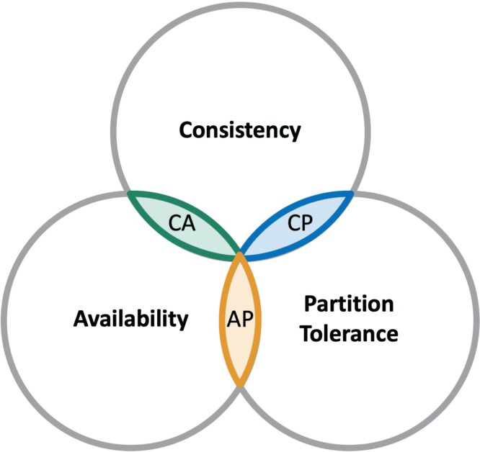

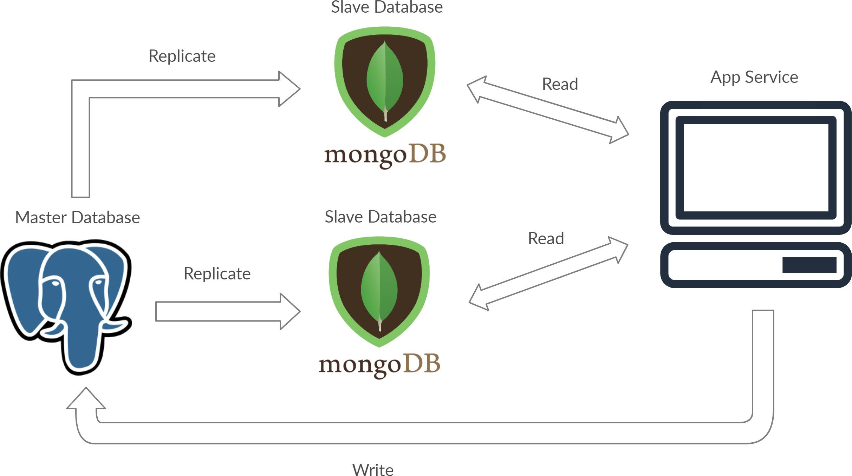

**LEC-21: The Master-Slave Database Concept**

1. Master-Slave is a general way to optimise IO in a system where number of requests goes way high that a single DB server is not able to handle it efficiently.

CodeHelp

1. Its a Pattern 3 in LEC-19 (Database Scaling Pattern). ***(Command Query Responsibility Segregation)***
2. The true or latest data is kept in the Master DB thus write operations are directed there. Reading ops are done only from slaves. This architecture serves the purpose of safeguarding site ***e***r ***liability, availability, reduce latency etc .*** If a site receives a lot of traffic and the only available

database is one master, it will be overloaded with reading and writing requests. Making the entire system slow for everyone on the site.

1. DB ***replication*** will take care of distributing data from Master machine to Slaves machines. This can be ***synchronous or asynchronous*** depending upon the system’s need.